K FELLFARERS CLOTHING ORDER FORM

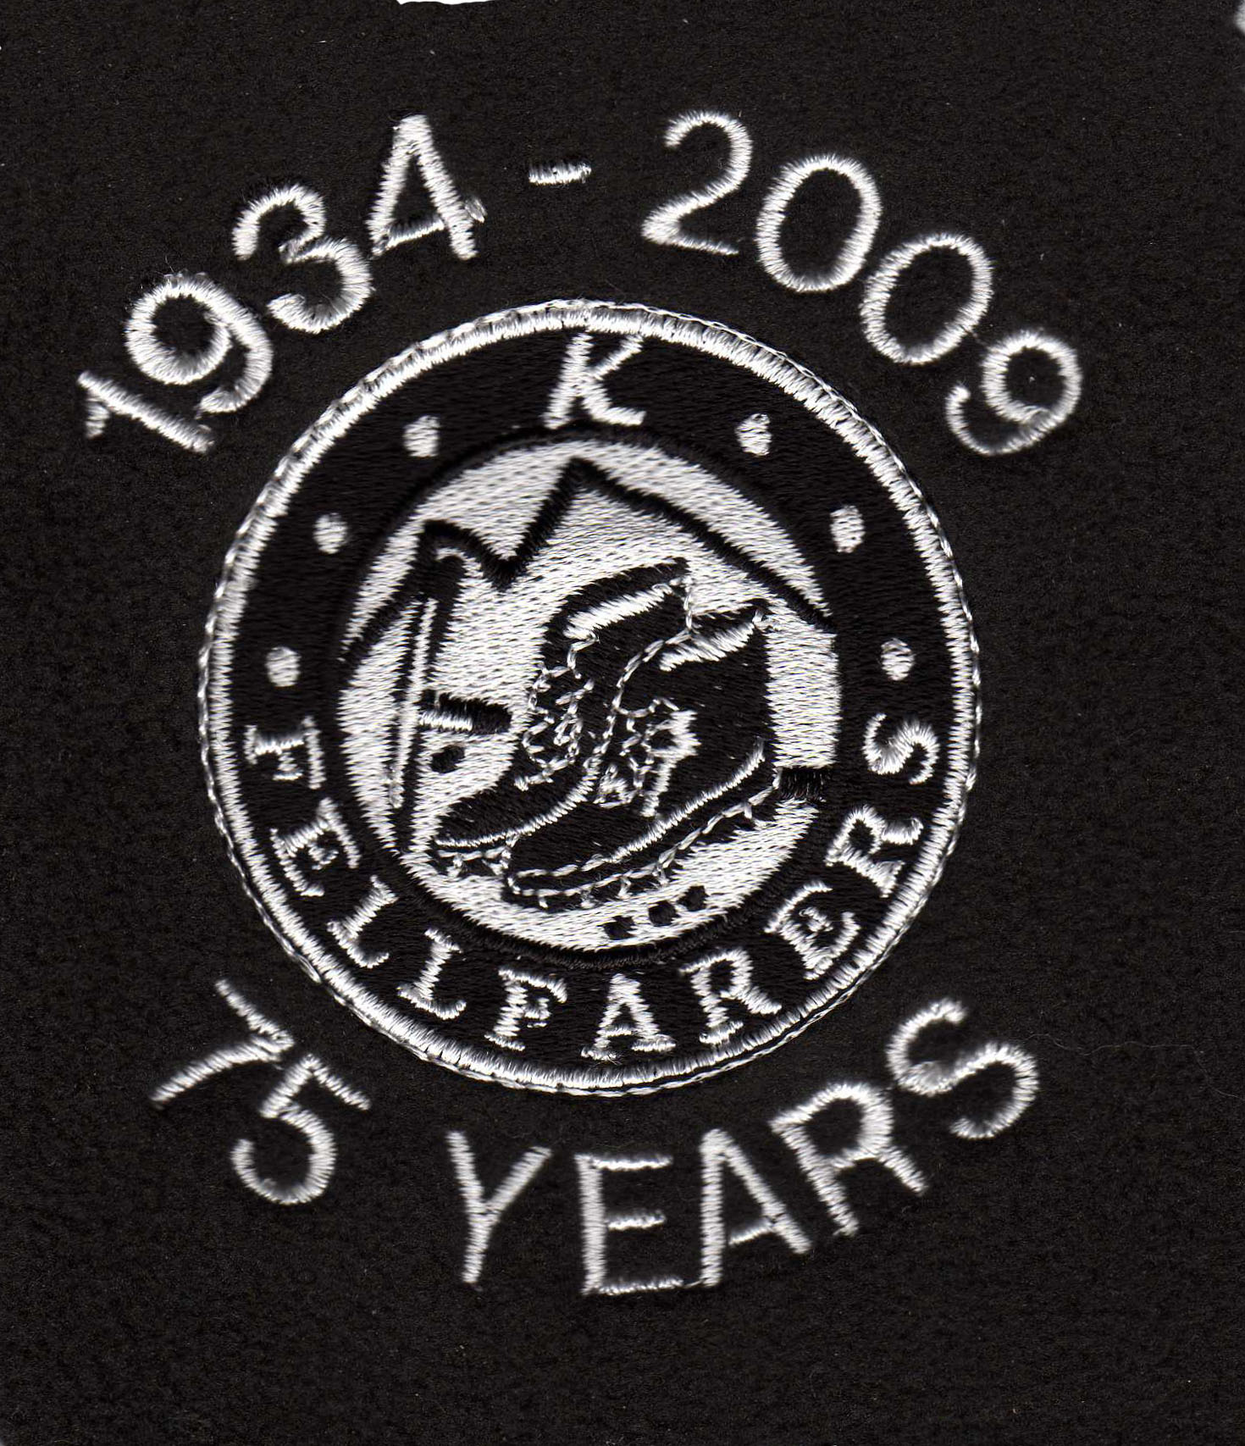

Logo to be specified with the 75 years, the 80 years, or none.

Name………………………………………..Address……………………………………………………….

………………………………………………………………………………………………………………….

Email…………………………………………………………. Phone no……………………………………

Send order to Mark Walsh, 20 Knutsford Road, Antrobus, Northwich, CW9 6JW
Or Email order to Mark at m-a-walsh@hotmail.co.uk
Clothing from Coniston Corporate UK Limited – www.corporate-embroidery.co.uk

Do check out the website and if you want anything different (i.e. micro fleece, children’s wear, etc) please give Mark the details and he’ll find out the price.
Orders will be collected from the factory and delivered to you at a convenient time/place to suit – eg working weekend, hut party….
You have the choice of whether you want the logo with the 75 years on it, with the 80 years on it, or with neither on it.
Cost includes embroidered logo and VAT, apart from sizes 14/15 in children’s wear, (add 15%).
If you want item(s) delivered to you personally then p & p will be extra (approx £2)

Product | Size |  | Colour
Adult ¼ zip outdoor fleece | XS 34/36 |  | Black
code 8740M | S 36/38 |  | Bottle Green
 | M 38/40 |  | Bright Blue
 | L 40/42 |  | Burgundy
 | XL 42/44 |  | Classic Red
 | 2XL 44/46 |  | Convoy Grey
 |  |  | French Navy
 |  |  | Orange
 |  |  | Sky
Kids ¼ zip outdoor fleece | 3/4 26in |  | Black
code 8740B | 5/6 28in |  | Bottle Green
 | 7/8 30in |  | Bright Blue
 | 9/11 32 in |  | Burgundy
 | 12/13 34in |  | Classic Red
 | 14/15 36in | + VAT | Sky
 |  |  | Convoy Grey
 |  |  | French Navy
Ladies full zip outdoor fleece | XS 8 |  | Black
code 8700F | S 10 |  | Bottle Green
 | M 12 |  | Bright Blue
 | L 14 |  | Burgundy
 | XL 16 |  | Classic Red
 | XXL 18 |  | Convoy Grey
 |  |  | French Navy
 |  |  | Orange
 |  |  | Sky
Men’s full zip outdoor fleece | XS 34/36 |  | Black
code 8700M | S 36/38 |  | Bottle Green
 | M 38/40 |  | Bright Blue
 | L 40/42 |  | Burgundy
 | XL 42/44 |  | Classic Red
 | 2XL 44/46 |  | Convoy Grey
 |  |  | French Navy
 |  |  | Orange
 |  |  | Sky
Ladies polo shirt | SX -8 |  | Black
code J539F | S-10 |  | Bottle Green
 | M-12 |  | Bright Red
 | L-14 |  | Bright Royal
 | XL-16 |  | Classic Red
 | XXL-18 |  | Lilac
 |  |  | French Navy
 |  |  | Sky
 |  |  | White
Men’s polo shirt | XS 34/36 |  | Birch
code J539M | S 36/38 |  | Black*
 | M 38/40 |  | Bottle Green*
 | L 40/42 |  | Bright Red
 | XL 42/44 |  | Bright Royal*+
 | 2XL44/46 |  | Classic Red*
 | 3XL46/48 | * | Pure Gold
 | 4XL48/50 | * | Purple
 | 5XL50/52 | + | Yellow
 | 6XL52/54 | + | Emerald
 |  |  | Burgundy
 |  |  | French/Navy*+
 |  |  | Light graphite
 |  |  | Light Oxford
 |  |  | White*+
 |  |  | Sky
Adult Sweatshirt | S 36/37 |  | Black
Fruit of the Loom | M 38/40 |  | Bottle Green
code SS200 | L 41/43 |  | Burgundy
 | XL 44/46 |  | Deep Navy
 | 2XL 47/49 |  | Heather
 |  |  | Khaki
 |  |  | Navy
 |  |  | Red
 |  |  | Royal Blue
 |  |  | Sky Blue
 |  |  | Sunflower
 |  |  | White
Kids Sweatshirt | 3/4 26in |  | Black
Fruit of the Loom | 5/6 28in |  | Bottle Green
code SS201 | 7/8 30in |  | Burgundy
 | 9/11 32 in |  | Deep Navy
 | 12/13 34in |  | Heather
 | 14/15 36in | + VAT | Khaki
 |  |  | Navy
 |  |  | Red
 |  |  | Royal Blue
 |  |  | Sky Blue
 |  |  | Sunflower
 |  |  | White

